Standard Operating Procedure
Procedure Title: | Authorization for Outside Lab/X-ray/US Orders for Patients with TriWest Insurance
Date: | 6/29/23
Version: | 1.5
Department: | Clinical
Approved By: | Brooke Gregory

Purpose: The purpose of this SOP is to outline the process for attaching authorization # when ordering outside labs, x-rays, and ultrasound (US) orders for patients with TriWest insurance.
Procedure: A patient with TriWest insurance has an order for labs, x-ray, and/or US that they would like to be done at an outside facility. Prior to sending the order(s), the medical assistant (MA) is to attach the TriWest VA auth # to each order.
- In the Alert note in each patient's chart the TriWest VA PCP auth # will be located at the top of the note.
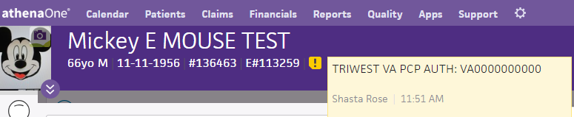
- MA to copy the auth # and paste it into the note section of each order being sent to an outside facility PRIOR to Athena faxing the order or printing it for the patient to take.
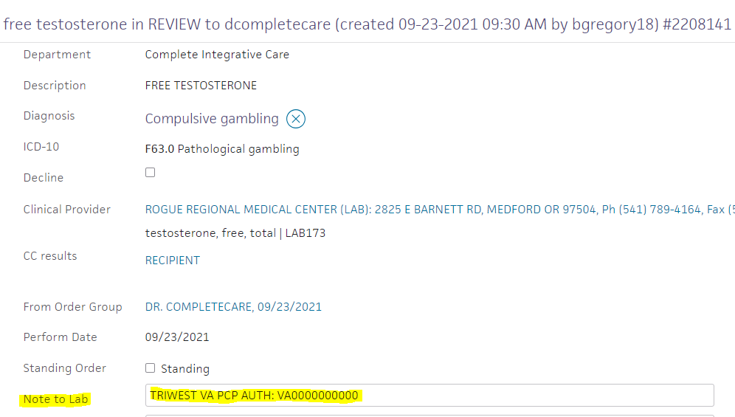
The veteran is ultimately responsible for assuring the facility they choose to complete their labs or imaging at has their authorization # on file and it is our responsibility to assist in streamlining the process for our patients.

